FX-ZZG50
自适应折盖封箱机
Adaptive lid folding and sealing machine
前言
欢迎使用自适应折盖封箱机，在使用本机前请认真阅读本说明书。
相关操作人员必需经培训考核合格后方可上岗操作机器，未经培训使用本机造成的事故或机器损坏等后果由使用厂家承担全部责任。在使用过程中有任何疑问或建议、欢迎向我公司反应，我们将虚心聆听、热情为您提供相关服务。
为了保证安全，机器运作中严禁无关人员靠近、触碰机器。
当机器出现故障时，应该及时告知机器 维护人员进行检修，或通知本公司。除人为损坏或无法抗拒的自然损坏之外，在保修期内我们为您提供免费服务，保修期过后进行有偿服务。客户在自行维修时应该注意安全，并且维护人员要熟悉机器，有一定的设备维修经验。
本说明书最终解释权归本公司所有，如有变更或升级不再另行通知。
Welcome to use the adaptive lid folding and sealing machine. Please read this manual carefully before using this machine.
The relevant operators must undergo training and pass the assessment before they can operate the machine. The consequences of accidents or machine damage caused by the use of this machine without training shall be borne entirely by the user manufacturer. If you have any questions or suggestions during use, please feel free to report to our company. We will listen humbly and provide you with relevant services with enthusiasm.
To ensure safety, unrelated personnel are strictly prohibited from approaching or touching the machine during operation.
When the machine malfunctions, it should be promptly notified to the machine maintenance personnel for inspection or to our company. Except for human damage or uncontrollable natural damage, we provide free services during the warranty period and paid services after the warranty period. Customers should pay attention to safety when repairing on their own, and maintenance personnel should be familiar with the machine and have some equipment repair experience.
The final interpretation of this manual belongs to our company, and any changes or upgrades will not be notified separately
目录contents

一、安全通则/general safety rules
二、设备简介/Equipment Introduction
2.1 设备概述/Equipment Overview....................................
2.2 设备简图/Equipment diagram......................................
2.3 环境要求/Environmental requirements............................
2.4 设备运输/Equipment transportation................................
2.5 设备主要配置/Main equipment configuration........................
三、主要技术参数Main technical parameters
四、原料与产品规格/Raw materials and product specifications
五、设备配置及结构说/Equipment configuration and structure theory
5.1 配件清单/parts list........................................
5.2 设备整体结构Overall structure of the equipment....................
5.3 封箱机机芯/Sealing machine core...............................
5.4 滚筒线/roller line..............................................
六、使用操作说明.Instructions for use and operation
6.1 卷封箱机机芯胶带安装要求Installation requirements for tape of the sealing machine core
6.2 胶带安装示意图Installation diagram of tape....................
6.3 胶带位置调整Adjustment of tape position........................
6.4 胶带张力调整Tape tension adjustment....................
6.5 封箱胶带异常排除说明Explanation for troubleshooting abnormal sealing tape
七、操作说明.Instructions for use and operation
7.1 开机前准备Preparations before starting up....................
7.2 启动与调试Startup and Debugging............................
7.3 正式封箱作业Formal box sealing operation........................
7.4 停机与复位Shutdown and reset.................................

八、维护与保养 Maintenance and upkeep
8.1 设备维护Equipment maintenance..............................
8.2 定期检查regular inspection................................
8.3 注意事项precautions................................
8.4售后服务after-sale service..............................
8.5 附录appendix................................................
九、装箱单packing list
十、合格证certificate of conformity

一 、安全通则/general safety rules
自适应折盖封箱机的操作、保养与维护必须由有充分培训并且考核合格的人员进行，他们必须熟悉机器的特点、功能与安全规则。
1.每一位被核定的操作者或保养与维护人员在操作机器前都必须认真学习本说明书，并彻底了解它。
2.操作者都必须遵守机器安全操作规程及保养的一切规则。
3.自适应折盖封箱机是专为快速封箱，节省人工成本，而设计的专用设备，不允许作其它用途。应考虑防止误用。
4.安全内容包括：安全指引，安全规则，事故预防和安全标识正确的操作等。
5.除了本说明书中的安全规则之外，还必须遵守通用的职业性的安全规则与当地安全法规和条例。
6.应防止所设计的安全装置、安全操作说明被损坏。
7.应防止机器上的明显标志被破坏。
8.安全标识、安全装置不能满足安全要求时，应立即修复或排除。
9.应保持机器工作场所干净、整齐。不要在机器或安全范围内暂放影响安全
操作的任何物品。
10.电气设备的安装或维修必须由有资格的人员进行。机器必须可靠接地，
防漏电危险。在任何电气安装或维修之后，应对电气安全特性方面进行测试。
11.操作者不要穿松散衣服；袖口要紧扣；长发者戴工作帽；不得戴手套操作。工作时最好不要戴珠宝等饰物。在需要时，应戴好眼睛、耳朵劳保用品。
12.开机前必须检查所有的安全装置是否可靠。
13.在下列情况之前，机器电源开关应处于关的位置，并挂警示牌：
①、检查、测量时；
②、做维护、保养、设置工作时；
③、取下保护罩时；
④、打开门或盖观察内部情况时；
⑤、离开机器时。
15.操作过程中严禁去掉任何安全罩盖，严禁启动安全保护装置不完好的机器。
16.严禁触动机器运转中或没有完全停止运转的零部件，严禁在机器运转时或没有完全停止运转时拆卸机器上的任何零部件。
17.机器运转中或未完全停止前，操作者不得离开。
18.机械或电器维修，必须先切断电源。
19.机器定期每天清洁，每开机前检查机器有无异常或固定螺丝有无松开。
20.收到机器时先检查机器在运输过程中有无受损，如果受损，应先把它记录下来，并尽快告知交运货物方。
21.除非检修机器，电器箱门不要随意打开，以防灰尘进入，造成故障。
22.不要用汽油、有机溶剂来清洁机器。
23.遇到紧急情况，请按急停开关，使机器停止。
24.操作、维护、安装本机器的人员，必须仔细阅读本说明书，熟悉本机器的
结构、性能。否则所造成的设备及伤害事故，后果自负。
The operation, maintenance and upkeep of the adaptive folding lid I-shaped box sealing machine (folding lid) must be carried out by fully trained and qualified personnel who must be familiar with the machine's features, functions and safety regulations.
1. Every approved operator or maintenance and maintenance personnel must carefully study this manual before operating the machine and thoroughly understand it.
2. Operators must comply with all the safety operating procedures and maintenance rules of the machine.
3. The fully automatic I-shaped carton sealing machine (automatic folding cover) is a special equipment designed for fast carton sealing and saving labor costs. It is not allowed to be used for other purposes. Preventing misuse should be considered.
4. Safety content includes: safety instructions, safety rules, accident prevention and correct operation of safety signs, etc.
5. In addition to the safety rules in this manual, general occupational safety rules and local safety laws and regulations must also be observed.
6. The designed safety devices and safety operating instructions should be prevented from being damaged.
7. The obvious signs on the machine should be prevented from being damaged.
8. When the safety signs and safety devices cannot meet the safety requirements, they should be repaired or eliminated immediately.
9. The machine workplace should be kept clean and tidy. Do not temporarily place any items that may affect safe operation in the machine or safety range.
10. The installation or maintenance of electrical equipment must be performed by qualified personnel. The machine must be reliably grounded to prevent leakage hazards. After any electrical installation or maintenance, the electrical safety characteristics should be tested.
11. Operators should not wear loose clothes; cuffs should be tightly buttoned; people with long hair should wear work hats; gloves should not be worn during operation. It is best not to wear jewelry and other accessories when working. When necessary, eye and ear protection equipment should be worn.
12. All safety devices must be checked for reliability before starting the machine.
13. Before the following situations, the machine power switch should be in the off position and a warning sign should be hung:
①, when checking and measuring;
②, when doing maintenance, maintenance, and setting work;
③, when removing the protective cover;
④, when opening the door or cover to observe the internal situation;
⑤, when leaving the machine.
15. It is strictly forbidden to remove any safety cover during operation, and it is strictly forbidden to start the machine with incomplete safety protection devices.
16. It is strictly forbidden to touch the parts of the machine when it is running or has not completely stopped. It is strictly forbidden to remove any parts on the machine when the machine is running or has not completely stopped.
17. The operator shall not leave the machine when it is running or before it has completely stopped.
18. The power supply must be cut off before repairing the machine or electrical appliances.
19. The machine should be cleaned regularly every day, and the machine should be checked for abnormalities or loosening of the fixing screws before each start-up.
20. When receiving the machine, first check whether the machine has been damaged during transportation. If it is damaged, it should be recorded first and informed as soon as possible.
21. Unless the machine is being repaired, the door of the electrical box should not be opened at will to prevent dust from entering and causing malfunctions.
22. Do not use gasoline or organic solvents to clean the machine.
23. In case of emergency, please press the emergency stop switch to stop the machine.
24. Personnel who operate, maintain, and install this machine must read this manual carefully and be familiar with the structure and performance of this machine. Otherwise, the equipment and injury accidents caused shall be borne by themselves.

二、设备简介Equipment Introduction
2.1设备概述Equipment Overview
自适应折盖封箱机是基于封箱、折盖、自动贴胶，为一体的自动封箱，使用者提供更加快捷的封箱效率，运用独家技术和精密机械技术，通过自动感应纸箱完成自动封箱折盖设备，实现对纸箱的稳定高效封箱；采用自动化控制，手动调节和自动调节，充分显示人性化操作理念。
The adaptive lid folding and sealing machine is an automatic sealing device that integrates sealing, lid folding and automatic gluing. It provides users with a faster sealing efficiency. By applying exclusive technology and precise mechanical technology, it completes the automatic sealing and lid folding equipment through automatic sensing of the carton, achieving stable and efficient sealing of the carton. It adopts automatic control, manual adjustment and automatic adjustment, fully demonstrating the concept of humanized operation.

生产工序流程： Production process flow:
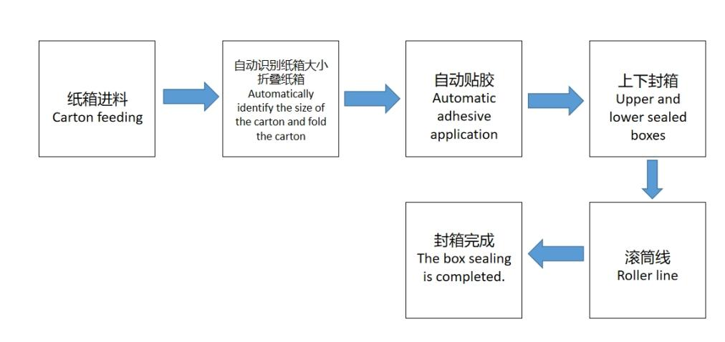
2.2设备简图（此图仅供参考，设备以实物为准）Equipment diagram (this diagram is for reference only, the actual equipment shall prevail)

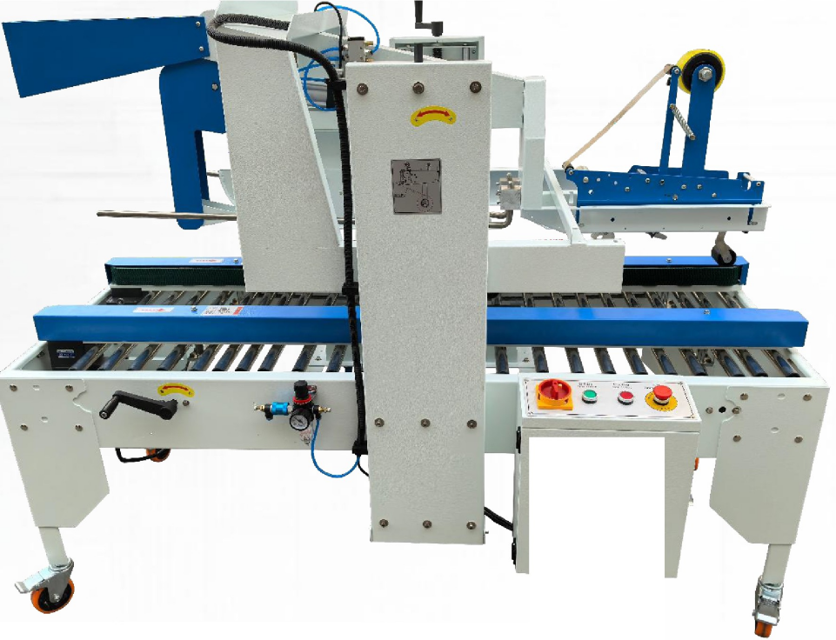

2.3 环境要求Environmental requirements
注意！机器必须防止湿气。不允许放置于户外。be careful! The machine must be protected from moisture. Not allowed to be placed outdoors

1）机器不能安装在有腐蚀性或易燃气体的环境中，预防机器损坏；
2）机器的安装处不能受到强微波、紫外线、激光、X 射线的辐射，以免造成误动作和加速绝缘老化；
3）机器的安装处避免受到振动，碰撞和冲击，远离振源安装；
4）机器的安装处避免雨淋的地方，禁止安装在露天的地方。
1) The machine cannot be installed in environments with corrosive or flammable gases to prevent damage to the machine;
2) The installation location of the machine should not be exposed to strong microwave, ultraviolet, laser, and X-ray radiation to avoid misoperation and accelerated insulation aging;
3) The installation location of the machine should avoid vibration, collision, and impact, and be installed away from the vibration source;
4) The installation location of the machine should avoid being exposed to rain, and it is prohibited to install it outdoors.

2.4 设备运输Equipment transportation
1）每台设备地脚处均安装有脚轮，在平地转运时，可以将脚杯收起，脚轮接触地面进行转移，
2）主机部分可以通过叉车进行转运，转运时需要对叉车进行软保护，叉车承载力大于 2.5 吨，注意叉车在设备重心位置，转运时平稳
Each device is equipped with casters at the foot, which can be retracted when transported on flat ground. The casters touch the ground for transfer,
2) The host part can be transported by forklift, and soft protection is required for the forklift during transportation. The forklift has a carrying capacity greater than 2.5 tons, and attention should be paid to placing the forklift at the center of gravity of the equipment for smooth transportation

2.5设备主要配置Main equipment configuration

主要配置Main configuration
序号Serial Number | 部件名称  Component Name | 数量  number | 备注  notes
1 | 自适应折盖封箱机  Adaptive lid folding and sealing machine | 1台
2 | 上下封机芯  Upper and lower sealed movement | 2个

主要电气元件项目Main electrical component projects

序号  Serial Number | 部件名称  Component Name | 数量number | 备注  notes
1 | 气缸cylinder | 4个
2 | 触控屏Touch screen | 1个
3 | 感应器a sensor | 4个
4 | 马达motor | 4个
5 | 按键key | 6个
6 | 电池阀Battery valve | 1个
7 | 三联件Frl | 1个 | 气管系统  tracheal system
8 | 电箱electric box | 1个
9 | 伺服Servo | 2个

三、主要技术参数Main technical parameters
序号  Serial Number | 名称name | 规格  specifications
1 | 生产厂家 Manufacturer | 华秀科技Huaxiu Technology
2 | 品名 Name | 自适应折盖封箱机  Adaptive lid folding and sealing machine sealing machine (folding lid)
3 | 型号 Model | FX-ZG50
4 | 功率/耗电 Power | 1400W
5 | 效率Efficiency | 约500箱/小时  7-12 boxes/minute
6 | 电压Voltage | 220V
7 | 气压Pressure | 6 kilograms
8 | 重量Weight | 约450kg
9 | 机器尺寸Measure | 长28-50cm,宽18-50cm,高18-50cm  Length 28-50cm, width 18-50cm, height 18-50cm
四、原料与产品规格

适用纸箱规格
序号 | 项目project | 规格参数Specification parameters
1 | 折盖封箱款Folding and sealing box style | 长13-50cm,宽11-50cm,高13-50cm  Length 13-50 unlimited cm, width 11-50cm, height 13-50cm
2 | 胶带adhesive tape | 4-5.5cm
3

- 设备配置及结构说明
- 5.1 配件清单
序号 | 部件名称Component Name | 备注notes
1 | 主机host | 1台
2 | 滚筒线roller line | 1条
3 | 封箱机芯Sealed box movement | 2个
5.2 设备整体结构
Overall structure of the equipment
自适应折盖封箱机，是基于封箱、折盖、自动贴胶为一体的自动折盖封箱，使用者提供更加快捷的封箱效率，运用独家技术和精密机械技术，通过自动感应纸箱完成自动封箱折盖设备，实现对纸箱的稳定高效封箱；采用自动化控制，手动调节和自动调节，充分显示人性化操作理念。
The adaptive lid folding and sealing machine is an automatic lid folding and sealing machine that integrates sealing, lid folding and automatic gluing. It provides users with a faster sealing efficiency. By applying exclusive technology and precise mechanical technology, it completes the automatic sealing and lid folding equipment through automatic sensing of the carton, achieving stable and efficient sealing of the carton. It adopts automatic control, manual adjustment and automatic adjustment, fully demonstrating the concept of humanized operation.
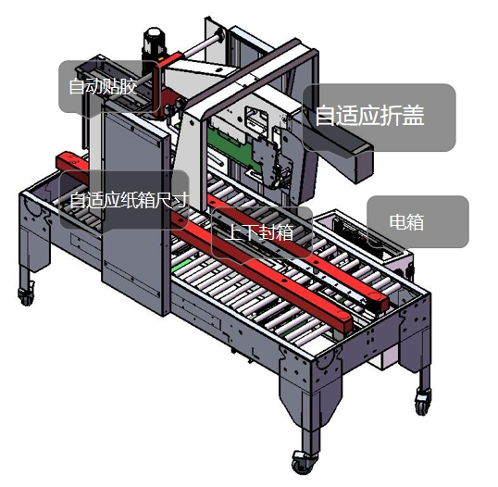

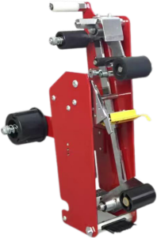
5.3封箱机机芯Sealing machine core
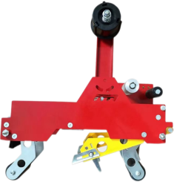
机芯组是折盖封和四角封箱的重要组成部分，实现
对纸箱的标准封箱快速封箱，分别有两大，上下封和
四角边封机芯，分别实现上下封箱，四角边封。提高
封箱利用率，保证封箱的平整一致性，每段贴胶结束
都会有自动切割，能对各个纸箱状态进行检测，减少
人工成本。
The movement assembly is an important component of the folding cover and four corner box, achieving
There are two standard quick sealing methods for cardboard boxes: top and bottom sealing
Four corner edge sealed movement, achieving upper and lower box sealing and four corner edge sealing respectively. increase
Sealing utilization rate, ensuring the flatness and consistency of sealing, and the end of each section of adhesive pasting
There will be automatic cutting, which can detect the status of each cardboard box and reduce
Labor costs.

5.4滚筒线roller line
封箱机工作中的输送线The conveyor line during the operation of the sealing machine
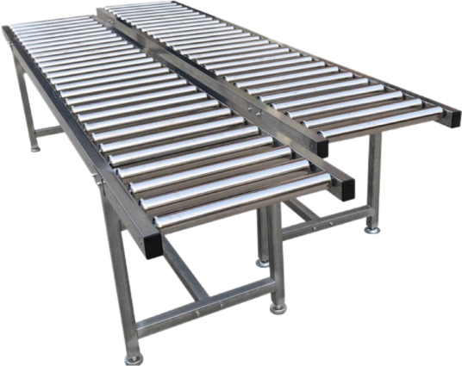

六、 使用操作说明Instructions for use and operation
6.1封箱机机芯胶带安装要求Installation requirements for sealing machine core tape
首先，将新OPP 胶带卷放入芯轴上，如图所示.第二，拉出胶带，绕过滚筒C 再
绕过滚筒B, 第三，绕过滚筒D,最后将胶带穿过胶带座E 从滚筒F 穿出，如下图所
示。在整个过程中一定要注意，胶带的粘性面一定要朝外。
Firstly, place the new OPP tape roll onto the core shaft as shown in the figure Secondly, pull out the tape and wrap it around drum C
Wrap around drum B, then around drum D, and finally pass the tape through tape holder E and out of drum F, as shown in the following figure
Show. Throughout the process, it is important to note that the adhesive surface of the tape must face outward.
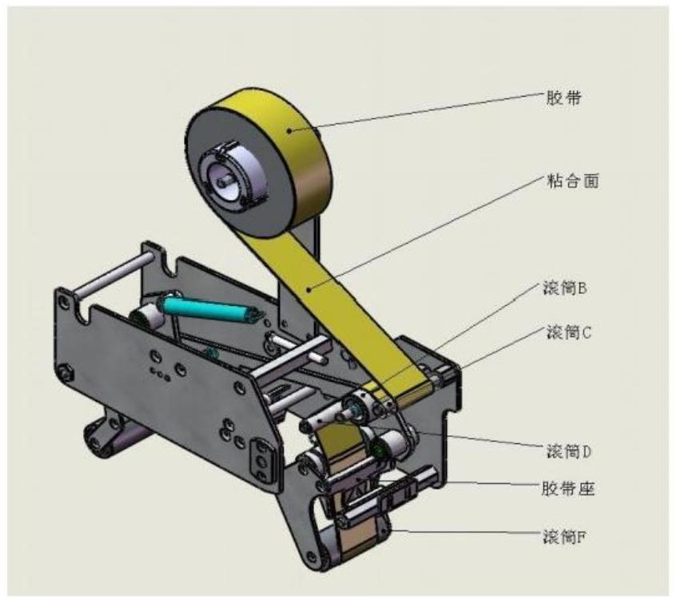
6.2胶带安装示意图Installation diagram of tape
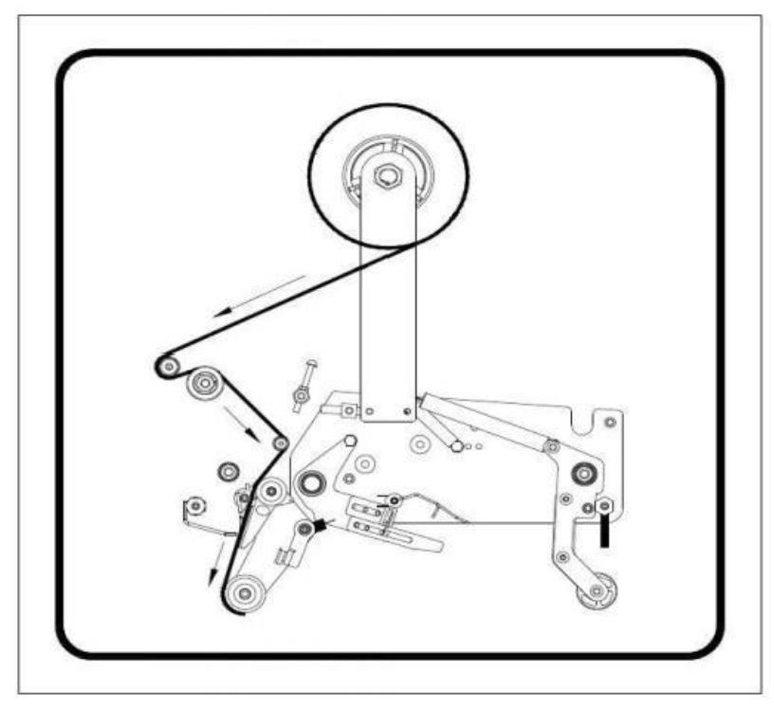

6.3胶带位置调整Adjustment of tape position
如果胶带不在箱子的中心线上，请参照下图进行调整：松开螺母 B, 然后用
螺丝刀调整心轴，从而可以调整胶带位置。
If the tape is not on the center line of the box, please adjust it according to the following diagram: loosen nut B, and then use
Adjust the spindle with a screwdriver to adjust the position of the tape
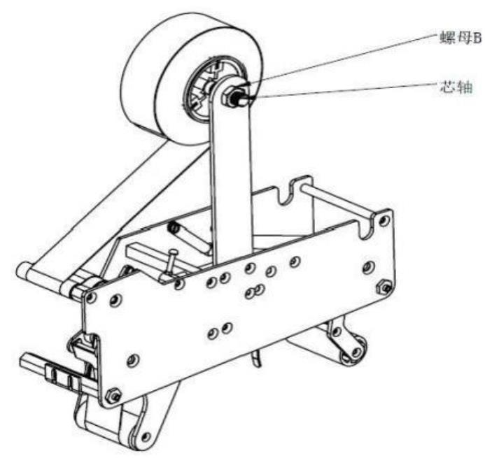
6.4胶带张力调整Tape tension adjustment
旋转旋钮，可以使胶带卷转速适中，并调松开螺母 M8, 调整螺钉 M8×50 的前
后位置，改变摆杆长拉簧的弹力,从而控制胶带张力的大小.顺时针旋转旋钮，胶
带张力变大，反之变小；螺钉 M8x50 向前调整，胶带张力变大，反之变小。
Rotate the knob to adjust the tape roll speed appropriately, loosen the nut M8, and adjust the front of the screw M8 × 50
Adjust the tension of the adhesive tape by changing the elasticity of the long tension spring of the swing rod in the rear position Rotate the knob clockwise, glue
The tension increases, and vice versa; When the screw M8x50 is adjusted forward, the belt tension becomes larger, and vice versa.
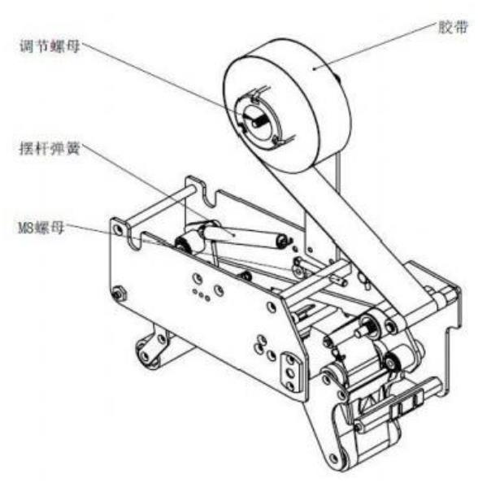
6.5封箱胶带异常排除说明Explanation for troubleshooting abnormal sealing tape
异常状态abnormal state | 原因reason | 排除方法Troubleshooting
胶带切不断  Tape cutting continuously | 刀片已不锋利或胶带膜卡  住刀尖  The blade is no longer sharp or the tape film is stuck  Stay at the tip of the knife | 更换刀片；擦干净刀片及  上油  Replace the blade; Clean the blade and  Oil up
胶带切不断  Tape cutting continuously | 刀片不够锋利  刀尖被粘合剂堵塞  The blade is not sharp enough  The tip of the knife is blocked by adhesive | 更换刀片；擦干净刀片及  上油  Replace the blade; Clean the blade and  Oil up
胶带已切断但拖一节  The tape has been cut but dragged one section | 刀座被卡住，动作不灵活 检查贴带器各部位螺丝，  或弹簧不够紧  The knife holder is stuck and the movement is not flexible. Check the screws of various parts of the tape applicator,  Or the spring is not tight enough | 检查贴带器各部位螺丝，  或弹簧不够紧  Check the screws of each part of the tape applicator,  Or the spring is not tight enough
胶带有切断但未贴合箱面  The tape has been cut but not adhered to the surface of the box | 主拉簧太松，后轮反弹速 适度锁紧主拉簧螺丝  The main tension spring is too loose, and the rear wheel rebound speed is moderate. Lock the main tension spring screw tightly | 适度无法与皮带速度吻合  Moderate cannot match the belt speed
纸箱走至中间被卡住不动  The cardboard box got stuck in the middle and couldn't move | 主拉簧太紧，前轮被陷在中间  The main tension spring is too tight, and the front wheel is stuck in the middle | 适度放松胶带轮主拉簧  Moderately relax the main tension spring of the tape roller
胶带容易落  Tape is prone to falling off | 单向滚轮失去效能  The one-way roller loses its effectiveness | 更换新单向滚轮  Replace the one-way roller with a new one
封箱后箱体偏歪及箱盖错角  The box body is skewed and the box cover is misaligned after sealing |  | 封箱前，箱盖折平后两侧  箱盖应与箱体对齐平行才  可推入封箱机进行封箱  Before sealing the box, fold the lid flat on both sides  The box cover should be aligned parallel to the box body  Can be pushed into the sealing machine for sealing
封箱后纸箱后段上的胶带  有皱纹或贴附下来的胶带  没有平整  Tape on the back section of the cardboard box after sealing  Wrinkles or adhesive tape attached  Not flat |  | 调 节 贴带器上的螺母M8  增大的拉力，如图9所示  Adjust the nut M8 on the tape applicator  Increased tensile force

旋转旋钮，可以使胶带卷转速适中，并调松开螺母 M8, 调整螺钉 M8×50 的前
后位置，改变摆杆长拉簧的弹力,从而控制胶带张力的大小.顺时针旋转旋钮，胶
带张力变大，反之变小；螺钉 M8x50 向前调整，胶带张力变大，反之变小。
Rotate the knob to adjust the tape roll speed appropriately, loosen the nut M8, and adjust the front of the screw M8 × 50
Adjust the tension of the adhesive tape by changing the elasticity of the long tension spring of the swing rod in the rear position Rotate the knob clockwise, glue
The tension increases, and vice versa; When the screw M8x50 is adjusted forward, the belt tension becomes larger, and vice versa.
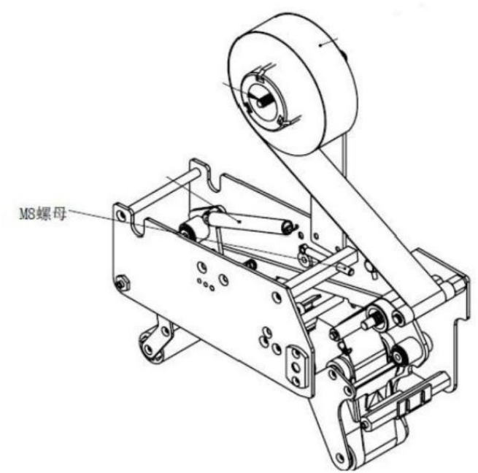
- 操作说明maintenance

7.1：开机前准备Preparations before starting up
设备检查：
清洁传送带表面杂物，检查胶带卷是否安装到位（胶带宽度建议40-55mm）。确认折盖导轨无变形，润滑链条与齿轮。
Equipment inspection:
Clean the debris on the surface of the conveyor belt and check whether the belt roll is installed properly (the recommended width of the belt is 40-55mm). Confirm that the guide rail for folding the cover is not deformed and lubricate the chain and gears.
连接气源：按照图片所示安装气管，滑动蓝色滑块右方向移动开启，常规气压调到0.4。Connect the air source: Install the air pipe as shown in the picture. Slide the blue slider to the right to open it. Set the regular air pressure to 0.4.
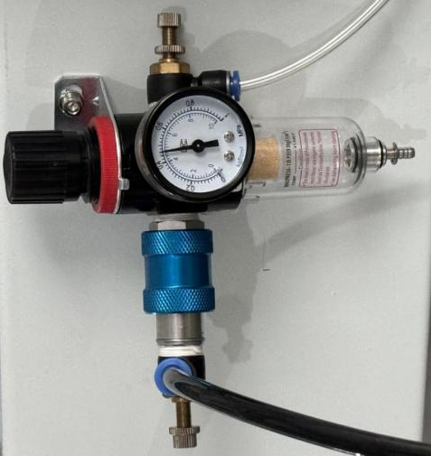
7.2：启动与调试Startup and Debugging
开机顺序 Startup sequence：
转动电源开关到ON →绿色指示灯亮起→进入系统→控制解除锁定按钮→设备处于急停状态顺时针扭动急停按钮→点击复位（设备会进行展开）→手动模式改为自动→然后点击启动页面 。
Turn the power switch to ON → The green indicator light will come on → Enter the system → Control the unlock button → The device is in the emergency stop state. Turn the emergency stop button clockwise → Click reset (the device will unfold) → Change the manual mode to automatic → Then click the start page
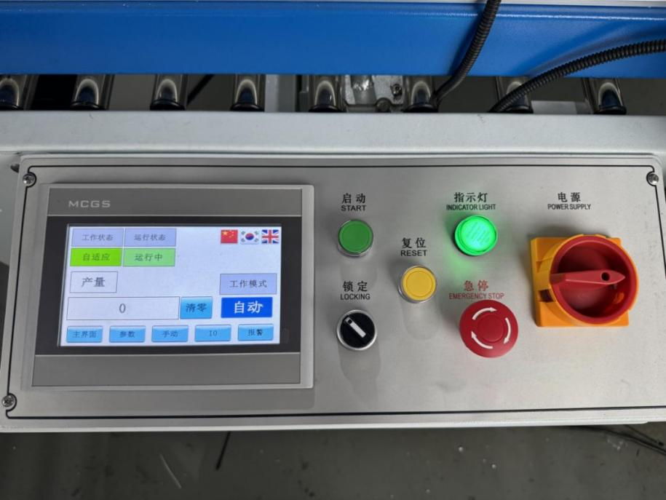
7.3：正式封箱作业Formal box sealing operation
进箱操作Box entry operation：
将纸箱放置于进料传送带，确保箱体与导向板平行。
设备自动感应纸箱，经折盖区完成上盖折叠、压平。
Box operation:Place the carton on the feeding conveyor belt and ensure that the box body is parallel to the guide plate.
The equipment automatically senses the carton and completes the folding and flattening of the upper cover through the lid-folding area.
封箱过程 Sealing process:
胶带输送装置在箱底粘贴横向胶带 → 自动识别纸箱大小→ 自动折叠纸箱→封箱完成。
The belt conveyor device adheres horizontal belt to the bottom of the box → automatically identifies the size of the carton → automatically folds the carton → the sealing is completed.出箱检测： Out-of-box inspection:
成品经出料口滑出，检查封箱胶带是否平整无褶皱，
The finished products slide out through the discharge port. Check whether the sealing tape is flat and free of wrinkles.7.4：停机与复位
正常停机：
点击屏幕“停止”键 → 待传送带清空后关闭主电源。
紧急停机：
触发急停按钮 → 排除故障后顺时针旋转按钮复位 → 重新启动系统。
Shutdown and reset
1. Normal shutdown:
Click the "Stop" button on the screen → Turn off the main power after the conveyor belt is empty.
2. Emergency shutdown:
Trigger the emergency stop button → After troubleshooting, rotate the button clockwise to reset → Restart the system.
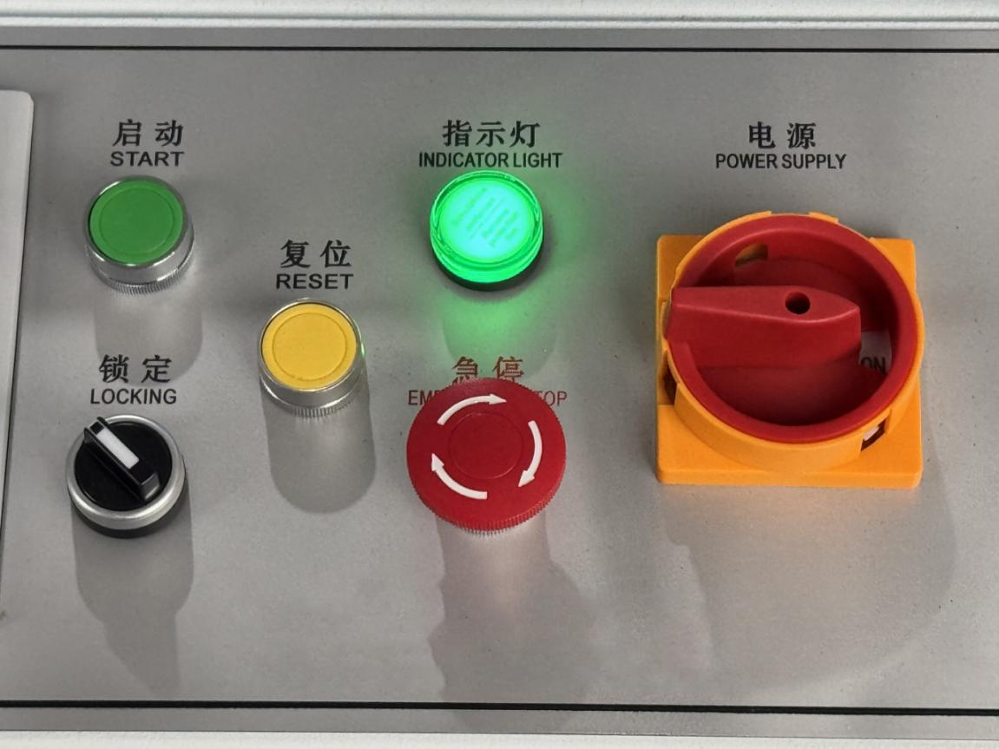
八、维护与保养maintenance
8.1 设备维护Equipment maintenance
为机械性能的维持以及寄希望的安全着想，并顾及生产技能的提高请常做以下各项检查：
(1) 保持整机的清洁,特别是在粉尘较重的工作环境中，应定期对本机械的进行维护与保养；
a) 清洁机器前，须得关闭机器电源；
b) 用干净捻湿的抹布擦拭机器工作台面及外表面
c) 用压缩空气清除鼻线部分的磨损尘粉
(2) 给油：各齿轮、链轮部分，涂上黄油，并补充或更换黄油；
(3) 去除各轮轴间杂污物；清除齿轮间异物；
(4) 各机构间结合螺母、螺丝是否松动，尤其是可调整部分的螺丝；
(5) 传动齿轮与链轮等组合是否有松动或异常；
(6) 各部分是否有损伤、变形、异常声音或其他的异状；
(7) 操作面板上的开关机指示灯是否有异常状况；
(8) 若机器上有防锈油，请务必清除，机器传动部位润滑处及注油部分要定期加注润滑油，保持良好的运行状态。
(9) 本机使用电源线路，请参照电气回路图装配保证机壳有效接地，防止出现静电或漏电，杜绝人身安全事故发生。不要在指定环境之外的条件下使用机器。
For the maintenance of mechanical performance and the safety of hope, while considering the improvement of production skills, please regularly perform the following checks:
(1) Keep the entire machine clean, especially in dusty working environments, and regularly maintain and upkeep the machinery;
a) Before cleaning the machine, the power supply must be turned off;
b) Wipe the machine workbench and outer surface with a clean and damp cloth
c) Use compressed air to remove worn dust and powder from the nose line section
(2) Oil supply: Apply butter to each gear and sprocket part, and replenish or replace the butter;
(3) Remove impurities between each wheel axle; Remove foreign objects between gears;
(4) Are the nuts and screws connecting various institutions loose, especially the screws in the adjustable parts;
(5) Is there any looseness or abnormality in the combination of transmission gears and sprockets;
(6) Are there any damages, deformations, abnormal sounds, or other abnormalities in each part;
(7) Is there any abnormal condition with the power on/off indicator light on the operation panel;
(8) If there is rust proof oil on the machine, please be sure to remove it. The lubrication and oil injection parts of the machine transmission should be regularly lubricated to maintain good operating conditions.
(9) This machine uses power circuits. Please refer to the electrical circuit diagram for assembly to ensure effective grounding of the casing, prevent static electricity or leakage, and prevent personal safety accidents. Do not use the machine under conditions outside the specified environment.
8.2 定期检查regular inspection
作业期间机器应每星期实施一次，除每天检查要项外，须施行下列检查：
1. 电子箱内的粉、灰尘要用吸尘器或软毛刷清除粉尘，
2. 外部电器配线检查。外部电源是否有变形、损伤、漏电或短路状况
3. 操作面板开关检查。面板按钮，接点是否导通，是否与油污附着
4. 控制盘内继电器的各接点是否良好
5. 伺服系统的检查。伺服系统应避免尘埃及腐蚀性物质，环境温度应保持至适
6. 齿轮、链轮磨损检查
⚫ 转动及动作是否有磨耗
⚫ 是否有油污附着
⚫ 接触部分是否磨耗
During the homework period, the machine should be inspected once a week. In addition to the daily inspection items, the following inspections must be carried out:
1. The powder and dust inside the electronic box should be cleaned with a vacuum cleaner or soft bristled brush,
2. Inspection of external electrical wiring. Is there any deformation, damage, leakage or short circuit in the external power supply
3. Check the operation panel switch. Whether the panel buttons and contacts are conductive and whether they are attached to oil stains
4. Are the contacts of the relays in the control panel in good condition
5. Inspection of servo system. The servo system should avoid dust and corrosive substances, and the ambient temperature should be maintained at an appropriate level
6. Gear and sprocket wear inspection
⚫ Is there any wear on the rotation and movement
⚫ Is there any oil contamination attached
⚫ Is the contact part worn
8.3 注意事项precautions
- 使用本机前，须详读本手册，并了解全部内容与指示。
- 机器需确认完成安装及必要的调整动作后，才能操作。
- 启动前需确认在机器所有台面没有放置任何工具或器物。
- 电源未关闭，不得触摸机器内部及电气设施。
- 机器在运转中，操作者不得离开机器工作范围。
- 非经本公司许可，不得任意改装机器，或在机器上接装任何非本公司认可的装置、刀具或周边设备，以免发生危险。
- 在使用本机出现故障时，立即关闭电源开关，以免损坏电子箱内电子原件及相关子程序配置，并及时同我公司售后服务部取得联系。
- 切忌自行打开电子箱，如有违背因此产生的一切损失均自行承担。
- 移动本机时，需轻拿轻放，安装要平稳。使机器能在最佳的条件下工作。
- 注意维护本机清洁卫生，用干净的软布轻轻擦拭。注意！不得用化学原料及硬物清洁擦拭电箱、机身，机身表面涂装乃静电粉沫烤制，一经损坏非油漆可补。
- 本机维护时严禁带电操作，避免人为人身安全。
- 机器工作时，严禁用手接触切刀及模具，避免高温烫伤和压伤。
- 机器的部件都不得随意增加和拆除，不得移用其它劣质配件更换、代替，以免影响已调试好的正常状态。
- 无论正常工作条件下及待机时，都严禁将手放在切刀刀片下，避免人为人身安全。
- 对终止工作或作某部分装置调整，务必先关掉电源
- 若检修气压装置，请先停止空压机并去除残留空气
- 若检修或调整电磁、压力装置、启动器等，必须有专业人员操作
- 1) Before using this machine, please read this manual carefully and understand all the content and instructions.
- 2) The machine can only be operated after confirming the completion of installation and necessary adjustment actions.
- 3) Before starting, it is necessary to confirm that there are no tools or objects placed on any countertops of the machine.
- 4) Do not touch the inside of the machine or electrical facilities until the power is turned off.
- 5) The operator must not leave the working range of the machine while it is in operation.
- 6) Without the permission of our company, it is not allowed to modify the machine or install any non approved devices, tools or peripheral equipment on the machine to avoid danger.
- 7) When a malfunction occurs while using this machine, immediately turn off the power switch to avoid damaging the electronic components and related subroutine configurations inside the electronic box, and promptly contact our company's after-sales service department.
- 8) Never open the electronic box by yourself. Any losses incurred as a result of violation shall be borne by yourself.
- 9) When moving the device, handle it gently and install it smoothly. Enable the machine to operate under optimal conditions.
- 10) Pay attention to maintaining the cleanliness and hygiene of this machine, gently wipe it with a clean soft cloth. be careful! Do not use chemical raw materials or hard objects to clean and wipe the electrical box and body. The surface coating of the body is baked with electrostatic powder, and once damaged, it cannot be repaired with paint.
- 11) It is strictly prohibited to operate the machine with electricity during maintenance to avoid personal safety.
- 12) When the machine is working, it is strictly prohibited to touch the cutting blade and mold with hands to avoid high temperature burns and pressure injuries.
- 13) The components of the machine shall not be arbitrarily added or removed, and other inferior parts shall not be replaced or substituted to avoid affecting the normal state that has been debugged.
- 14) It is strictly prohibited to place hands under the cutting blade under normal working conditions and standby mode to avoid personal safety.
- 15) Before terminating work or making adjustments to a certain part of the device, be sure to turn off the power first
- 16) If repairing the air pressure device, please stop the air compressor first and remove residual air
- 17) If repairing or adjusting electromagnetic, pressure devices, starters, etc., professional personnel must operate them

8.4 售后服务：after-sale service
请参照上述操作指令进行操作。若本说明书内容有任何不明了之处，或出现其它质量事故，请致电至生产厂家，以便得到更好的售后服务。
Please refer to the above operation instructions for operation. If there is any ambiguity in the content of this manual or if there are any other quality accidents, please call the manufacturer for better after-sales service.

8.5附录appendix
设备保养计划表Equipment Maintenance Schedule

部门department 年 月 日
序号Serial Number | 设备编号Equipment number | 设备名称Equipment name | 保养内容Maintenance content | 保养周期service interval | 保养时间Maintenance Time | 保养人Maintainer | 完成情况Completion status
计划编制人：  日 期： |  |  | 审 核 人：  日 期： |  | 批 准 人：  日 期：

九：装箱单packing list
装箱单packing list
序号Serial Number | 名称及规格  Name and specifications | 数量number | 备注  notes

十:合格证 certificate of conformity
合格证明书

本产品检验合格，准予出厂

设备名称_____________________
型 号_____________________
机身编号_____________________
检 验 员_____________________
日 期_____________________

certificate of compliance
This product has passed the inspection and is allowed to leave the factory

Equipment name _____________________
Model number _____________________
Body number _____________________
Inspector _____________________
Date _____________________

